#Import the necessary libraries

from sklearn.datasets import load_breast_cancer

from sklearn.model_selection import train_test_split

from sklearn.tree import DecisionTreeClassifier

from sklearn.metrics import confusion_matrix

import seaborn as sns

import matplotlib.pyplot as plt

from sklearn.metrics import accuracy_score, precision_score, recall_score, f1_score

# Load the breast cancer dataset

X, y= load_breast_cancer(return_X_y=True)

X_train, X_test, y_train, y_test = train_test_split(X, y,test_size=0.25)

# Train the model

tree = DecisionTreeClassifier(random_state=23)

tree.fit(X_train, y_train)

# preduction

y_pred = tree.predict(X_test)

# compute the confusion matrix

cm = confusion_matrix(y_test,y_pred)

#Plot the confusion matrix.

sns.heatmap(cm,

annot=True,

fmt='g',

xticklabels=['malignant', 'benign'],

yticklabels=['malignant', 'benign'])

plt.ylabel('Prediction',fontsize=13)

plt.xlabel('Actual',fontsize=13)

plt.title('Confusion Matrix',fontsize=17)

plt.show()

# Finding precision and recall

accuracy = accuracy_score(y_test, y_pred)

print("Accuracy :", accuracy)

precision = precision_score(y_test, y_pred)

print("Precision :", precision)

recall = recall_score(y_test, y_pred)

print("Recall :", recall)

F1_score = f1_score(y_test, y_pred)

print("F1-score :", F1_score)

output:

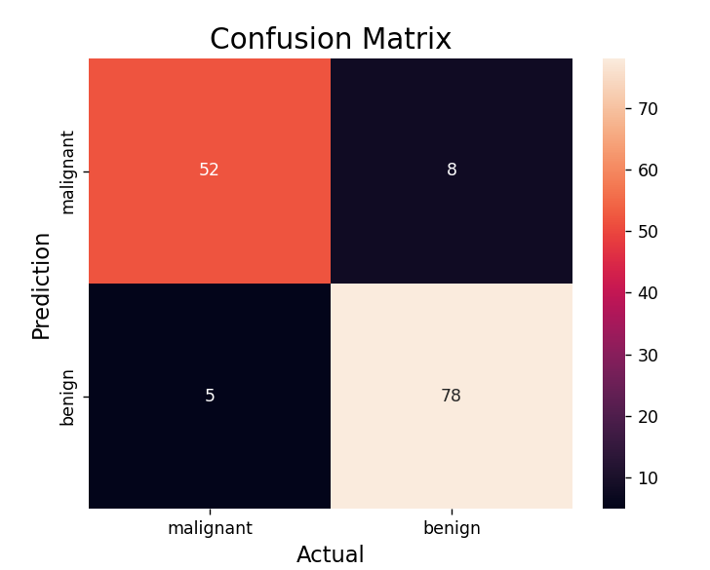

Accuracy : 0.9090909090909091

Precision : 0.9069767441860465

Recall : 0.9397590361445783

F1-score : 0.923076923076923